February 19, 2022

*Via E-mail:* <<ADJUSTER_EMAIL>>

<<INSURANCECOMPANY_SUITNAME>>

c/o Claims Department

***RE: Letter of Representation***

**Insured:** <<INJUREDPARTY_NAME>>

**Property Address:** <<INJUREDPARTY_FULL_ADDRESS>>

**Claim No.:** <<INS_CLAIM_NUMBER>>

**Date of Loss:** <<ACCIDENT_DATE>>

To whom it may concern:

Please allow this correspondence to serve a letter of representation of our client, <<PROVIDER_SUITNAME>>, in the above-referenced matter. Any and all future communications regarding this matter should be made directly to my office. We hereby request a certified copy of the subject policy of insurance relating to this claim.

Should you have any questions or would like to discuss this matter further, please do not hesitate to contact my office. Thank you.

Sincerely,

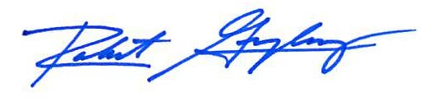

Robert F. Gonzalez, Esq.